Proceedings

Optimal Missing Value Estimation Algorithm for Groundwater Levels †

Klemen Kenda 1,2,\*, Filip Koprivec 1 and Dunja Mladenić 1,2

1 Artificial Intelligence Laboratory, Jožef Stefan Institute, Ljubljana, 1000, Slovenia

2 Jožef Stefan International Postgraduate School, Ljubljana, 1000, Slovenia

klemen.kenda@ijs.si, koprivec.filip@gmail.com, dunja.mladenic@ijs.si

**\*** Correspondence: klemen.kenda@ijs.si; Tel.: +386-31-420-418

† Presented at the 3rd EWaS International Conference on “Insights on the Water-Energy-Food Nexus”, Lefkada Island, Greece, 27-30 June 2018.

Published: date (leave it empty)

**Abstract:** .

**Keywords:** missing values, data cleaning, data fusion, machine learning, ensembles

1. Introduction

Groundwater is an important indicator of changes in the climate. To assess the changes in comparison to groundwater withdrawal and different land-use long term availability of the data is needed. Usually different sensors for measuring groundwater levels are active in different time periods and might be subjected to very different properties of collected data (frequency, precision, etc.). In this paper we present a missing value estimation algorithm based on available data from active near-by sources and test it on data available from Ljubljana aquifer. Groundwater level measurements for Ljubljana aquifer are quite sparse. First measurements have been conducted in 1949 by one sensor and no sensor has measured groundwater levels continuously up until the present day. There are time intervals with more active sensors (1967-1971, 2002 – 2017), however – in between only a few sensors have been recording measurements. Additionally – each sensor has random missing values during the intervals, when measurements have been taken and also frequencies of data measurements change significantly between different time periods.

There are a plethora of reasons for missing data: hardware or software malfunction, human error (in the early measurements of groundwater), intentional removal (when data is corrupted). We choose the process of data imputation to deal with missing values, which means that we want to approximate the missing data points. There are many different ways to impute missing values. We can substitute a missing value with a mean, with a substitute from another individual, from a hot deck (randomly chosen value from an individual who has similar other variables), cold-deck (like in hot-deck, but the individual is chosen systematically), with regression (based on other variables), stochastic regression (adding a random residual value to regression), interpolation and extrapolation (estimate from the other observations from the same individual).

Authors of [1] propose usage of regression tree for missing data imputation of sparsely sampled time-series. Their models rely on nearby sensors’ measurements. They propose the usage of linear interpolation at a pre-processing step to improve model accuracies. We also use linear regression interpolation within the sparse datasets, but also propose usage of b-splines. In addition to regression trees we also test other methods like linear regression, random forests and support vector machines. We propose the usage of the optimal algorithm and optimal feature set.

Authors of [2] report on usage of simple (interpolation with last value and mean) and sophisticated methods, such as linear regression and PCA. Tensor-based methods also produce very good results in estimating missing values [3]. In some (extreme) cases missing values were successfully imputed with this method, where data of one or several days were completely missing.

In [4] authors use short-term Kalman filter models for imputation of missing or corrupt time-series data in a streaming scenario. Their method is dedicated to detection and substitution of single outliers with linear methods, whereas our approach can substitute larger chunks of missing data with more complex methods. Our approach could be extended into outlier detection algorithm.

In groundwater missing data imputation [5] suggested groundwater nitrate monitoring network optimization with reduction of measuring nodes. They estimate errors at missing nodes with linear methods. In our work we take a similar approach, but do not care about network reduction.

Authors of [6] suggest the usage of hot-deck imputation method on a global scale, where they replace missing values with a value from the donor cases, which match the recipient node in a set of specified variables from the same dataset. Value is chosen randomly or from the deck with the closes similarity. In our work the target node has been observed before therefore regression models can provide better estimations.

In this work we try to estimate missing values of a particular sensor based on the data-driven regression models with attributes from the neighboring sensors. We model each sensor with an ensemble of different data-driven models with all available combinations of adjacent sensors. Our algorithm selects the most accurate model (with lowest estimated error) and uses it to predict missing values at a particular time. Final result of our algorithm is the full dataset of all available sensors in the system, which can be used for further climate and urban-planning studies.

2. Materials and Methods

2.1. Data and Data Acquisition

We have used groundwater data of Ljubljana polje aquifer available at an online repository at Slovenian Environment Agency[[1]](#footnote-1). Raw data has been downloaded, parsed and used for experiments. We have chosen a subset of 12 sensors from narrower Ljubljana city region, which have data available during the last decade. Each sensor has a unique identifier, which ranges from 85004 to 85076 for this particular dataset. For each sensor, data was parsed and converted to amsl (above mean sea level) values, since some sensors reported mixed data values (relative water level and absolute water level). Time range of valid measurements was constructed for each sensor and missing values in valid time range were interpolated using B-splines of order 3 (initial data analysis showed marginal improvement when interpolating using B-splines compared to linear interpolation for shorter missing data intervals, e.g. 2 weeks). Sensor data was merged into the same time interval and time ranges with suitable number of functioning sensors were analyzed individually.

2.3.1. Modeling Methods

Data-driven techniques have been used to approximate missing data with measurements from related sensors. This problem describes a classical regression task. Numerous regression methods have been tested. We have tried simple and fast linear regression [7] (which is useful due to its speed; many models with different combinations of available measurements can be generated almost instantly) and other more advanced (but slower techniques) like random forest regression [8] and support vector regression. Advanced techniques can in certain cases capture different non-linear relations between different groundwater level sensors.

3. Results

3.1. Exploratory Data Analysis

The whole groundwater levels database includes measurements from early 1950s until present time. Measurements are sparse during middle period (1970-2008) and very sparsely acquired in first period (frequency of data acquisition in years between 1950 and 1970 varies, but rarely exceeds more than 2 measurements per month). Time range with more frequent and reliable data points was selected for experiments. This is crucial, since our method for estimation of missing data relies on nearby sensors and availability of their data. Time range from beginning of year 2013 until the end of 2015 was selected, consisting of 1092 different measurements per measurement station.

During this period 12 measurement stations were active. Stations can be grouped into 5 different clusters, as seen from the correlation matrix in Figure 1 or from their plots in Figure 2. We can see 4 similar clusters (top of the figure) and two sensors in the last one (85012 and 85073), which significantly deviate from others. Sensor 85076 is a bit different due to a large portion of missing data. Other measurements seem to follow roughly similar pattern, but with varying amplitude and some individual features.

3.2. Modeling and evaluation

Measurements from each station have been modeled with a combination of measurements from other station (predictors) by linear regression, support vector regressor and random forest regressor. For each station, optimal subset of predictors and modeling algorithm were selected according to R2 score (full dataset was split with ratio of 7:3 into train and test set respectively; each model was evaluated on the same test-set).

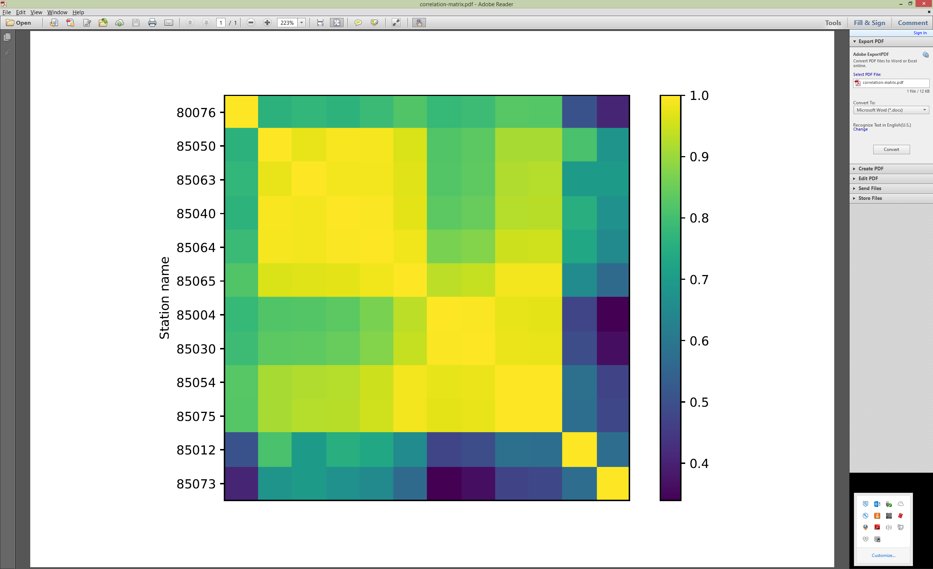

**Figure 1**: Correlation matrix of groundwater levels from different stations. Stations have been hierarchically clustered – similar stations are depicted nearby. We can observe 5 distinct clusters (similar types of rows) in the matrix, which represent 5 typical groundwater regimes. Two stations at the bottom deviate significantly from all others.

Results of optimal combinations of predictors and modeling algorithms are presented in Table 1. First line includes average values of R2 and RMSE (with standard deviation in parenthesis) for 10 similar sensors (last two are presented separately), optimal predictors are not presented, as they vary from station to station (optimal combination includes from 5 to 11 adjacent sensors as predictors). Interestingly, station 85012 (significantly different) is always present as predictor, although its correlation with other sensor is very small. Optimal predictors are presented as last two digits of sensor id, as numbered in Figure 2.

**Table 1**: Modeling results for different (groups of) sensors.

|  |  |  |  |  |
| --- | --- | --- | --- | --- |
| **Sensor** | **R2** | **RMSE** | **Optimal algorithm** | **Optimal predictors** |
| all | 0.9976 (+/-0.0028) | 0.0318 (+/-0.0244) | Linear regression | different |
| 85012 | 0.9388 | 0.0993 | Linear regression | 04, 50, 54, 63, 64, 65, 73, 75 |
| 85073 | 0.8572 | 2.7233 | Random forest | 04, 30, 50, 54, 63 |

Prediction results of our methodology are extremely good. Highly correlated sensors can be modeled with one another almost perfectly with R2 scores are close to 1. On average our algorithm misses by 3 cm. Even the two different sensors (85037 and 85012) have been predicted fairly accurately (R2 higher than 0.85), which shows the strength of the data-driven approach. Figure 3 depicts sensor 85067, which has true missing values within our test period.

multifig_measurements-predictions2-V.pdf

**Figure 2**: Real (blue) and predicted (orange) values of groundwater level at different stations.

missing_prediction-only.pdf

**Figure 3**: Prediction of missing values for sensor 85067, blue line (right) represents true values, orange line depicts groundwater level predictions over true measurements (right).

4. Discussion

**Acknowledgments:** The work described in this paper has been conducted within the projects Water4Cities and PerceptiveSentinel. Both projects have received funding from the European Union’s Horizon 2020 programmes. Water4Cities is a Research and Innovation Staff Exchange project under grant agreement number 734409. PerceptiveSentinel is a Research and Innovation project under grant agreement number 776115. This paper and the content included in it do not represent the opinion of the European Union, and the European Union is not responsible for any use that might be made of its content.

**Author Contributions:** Klemen Kenda conceived and designed the experiments and wrote the paper; Filip Koprivec performed the experiments; Dunja Mladenić provided additional analysis of the data.

**Conflicts of Interest:** The authors declare no conflict of interest.

References

1. Higashijima, Y., Yamamoto, A. , Nakamura, T., Nakamura, M., Matsuo, M. Missing Data Imputation Using Regression Tree Model for Sparse Data Collected via Wide Area Ubiquitous Network, 2010 10th IEEE/IPSJ International Symposium on Applications and the Internet, Seoul, 2010, pp. 189-192. doi: 10.1109/SAINT.2010.18
2. Lopes, J., Bento, J., Huang, E. Traffic and mobility data collection for real-time applications. (ITSC), 2010 13th …, 2010.
3. H. Tan, G. Feng, J. Feng, W. Wang, Y.-J. Zhang, and F. Li, “A tensor-based method for missing traffic data completion,” Transportation Research Part C: Emerging Technologies, vol. 28, pp. 15–27, Mar. 2013.
4. Kenda, K., Mladenić, D. Autonomous Sensor Data Cleaning in Stream Mining Setting. *Business Systems Research Journal* **2019**, Vol.: 9 (in press).
5. Nunes, L. M., E. Paralta, M. C. Cunha, and L. Ribeiro (2004), Groundwater nitrate monitoring network optimization with missing data, Water Resour. Res., 40, W02406, doi: 10.1029/2003WR002469.
6. Srebotnjak, T., Carr, G., de Sherbinin, A., Rickwood, C., A global Water Quality Index and hot-deck imputation of missing data, Ecological Indicators 2012, Vol. 17, pp. 108-119, doi: 10.1016/j.ecolind.2011.04.023.
7. Hastie, T., Tibshirani, R., Friedman, J. *The Elements of Statistical Learning,* 2nd ed.; Springer: New York, 2017, pp. 43-100.
8. Breiman, L. Random forests. *Machine learning* **2001**. Vol.: 45, pp. 5-32.

H:\documents\layout\new template June 2014\figures\CC-BY logo original v1.wmf© 2018 by the authors. Submitted for possible open access publication under the   
terms and conditions of the Creative Commons Attribution (CC BY) license (http://creativecommons.org/licenses/by/4.0/)

1. http://vode.arso.gov.si/hidarhiv/pod\_arhiv\_tab.php [↑](#footnote-ref-1)